eTaap Developer’s Guide

Created by

eTouch Systems Corp

Revision History

|  |  |  |  |
| --- | --- | --- | --- |
| * **Version No.** | * **Date** | * **Name (Alias)** | * **Description of Change** |
| * 1.0 | * 08/05/2014 | * eTouch | * Created Developer Guide |
| * 2.0 | * 12/10/2014 | * eTouch | * Updated Developer Guide |
| * 3.0 | * 12/20/2014 | * eTouch | * Updated Developer Guide |
| * 4.0 | * 1/23/2015 | * eTouch | * Formatted the document |



Table of Contents

1. Introduction 5

2. Installation 6

2.1Project installation from GitHub 8

2.2Installing external jars in the local repository 17

3. About Test Automation Library 36

3.1Package - com.etouch.taf.core 40

3.1.1 TestBedManager.java 40

3.1.2 TestSuiteManager.java 41

3.2Package - com.etouch.taf.core.config 42

3.2.1 TestBedConfig.java 42

3.2.2 TestBedManagerConfiguration.java 43

3.2.3 DefectConfig.java 44

3.3Package - com.etouch.taf.core.datamanager.excel 45

3.3.1 TafExcelDataProvider.java 45

3.3.2 TestDataContainer.java 46

3.3.3 TestDataKey.java 47

3.4Package - com.etouch.taf.dataprovider.annotations 48

3.4.1 IExcelDataFiles.java 48

3.4.2 TafExcelDataProviderInput.java 48

3.5Package - com.etouch.taf.core.driver 49

3.5.1 DriverBuilder.java 49

3.5.2 DriverConstsntUtil.java 50

3.6Package - com.etouch.taf.core.driver.mobile 50

3.6.1 AndroidDriver.java 50

3.7Package - com.etouch.taf.mobile.appium 51

3.7.1 AppiumDriver.java 51

3.8Package - com.etouch.taf.tools.defect 52

3.8.1 IDefectManager.java 52

3.9Package - com.etouch.taf.tools.defect.jira 53

3.9.1 jira.java 53

3.9.2 jiraConstants.java 54

3.10Package - com.etouch.taf.tools.defect.rally 54

3.10.1 Rally.java 54

3.10.2 RallyInfo.java 55

3.11Package - com.etouch.taf.util 56

3.11.1 CommonUtil.java 56

3.11.2 ConfigUtil.java 57

3.12Package - com.etouch.taf.webui.selenium 58

3.12.1 SeleniumDriver.java 58

3.12.2 WebPager.java 59

4. Amazon POC 60

4.1About Test-Automation-Scripts 60

4.1.1 Pom.xml 61

4.1.2 TestAmazonUnit.java 62

4.1.3 CommonPage.java 63

4.1.4 SuiteListner.java 64

4.1.5 testautomation.log 65

5. Flow diagram 66

6. Logging Defect in Defect Management System 69

6.1Log the defect in Rally 69

6.2Log the defect in Jira 70

7. General Information 71

8. Appendix 72

# **Introduction**

* Ensuring that a web application works and continues to work as per the specifications on a set of different supported browsers is an essential part of web application development lifecycle. Web Developers can use the eTouch Test Automation Framework (TAF) to rapidly build and run regression test suites.

# **Installation**

**Target Audience:** Newly joined team members.

* **Perquisites:** (Make sure that you meet all the pre-requisites before proceeding with the setup of the Project)
* 1. Installed Eclipse Kepler version 2 or higher,
* Ref: <http://eclipse.org/downloads/packages/eclipse-ide-java-ee-developers/keplersr2>[1]
* 2. Maven 3.2.3 or higher installed in your system. Please refer to the Note below to set up the environment variables for Maven.

Ref: <http://maven.apache.org/download.cgi>

* 3. Apache ant 1.9.4. Please refer to the Note below to set up the environment variables for ant.
* Ref: <http://ant.apache.org/bindownload.cgi>
* 4. Jdk 1.6 update 32 or higher,
* 5. Get the GitHub account id/password from eTouch Systems Corp to download the repository.

**Eclipse plugins Installation**

1. EGit plugin installed in eclipse - To install EGit plugin, go to eclipse -> help -> Eclipse Marketplace.., Search with “EGit” and install EGit – Git Team Provider 3.5.2.
2. Maven plugin (m2e) installed in eclipse - To install m2e plugin, go to eclipse -> help -> Eclipse Marketplace.., Search with “m2e” and install Maven Integration for Eclipse.

* **Resources: (**Be sure torefer the resources)

1. GitHub eTouch link –

<https://github.com/etouchsystemscorp/Test-Automation-Prod.git>

1. Name of repository on GitHub - Test-Automation-Prod
2. Link to eTouch same page wiki - <http://etaap.spwiki.com/cm/newui/wiki/index.jsp>

**Note:**

1. Any version of Internet Explorer, Chrome, Firefox and Safari can be used for testing.
2. Please add/edit the below maven environment variables under system or user group. All the variables should be added under the same group.

* M3_HOME = <Maven installation Folder>\apache-maven-3.2.3-bin\apache-maven-3.2.3
* PATH = ;%M3_HOME%\bin

1. Please add/edit the below ant variables under system or user group. All the variables should be added under the same group.
   * ANT_HOME= <Ant installation folder>\apache-ant-1.9.4-bin\apache-ant-1.9.4
   * PATH=;%ANT_HOME%\bin

## Project installation from GitHub

* Please follow the steps below to start your setup process (Please refer to screen shots):

1. Open Eclipse---> Goto "File" tab and select "Import". Now, select the "Git---> Projects from Git" and press "Next" button.

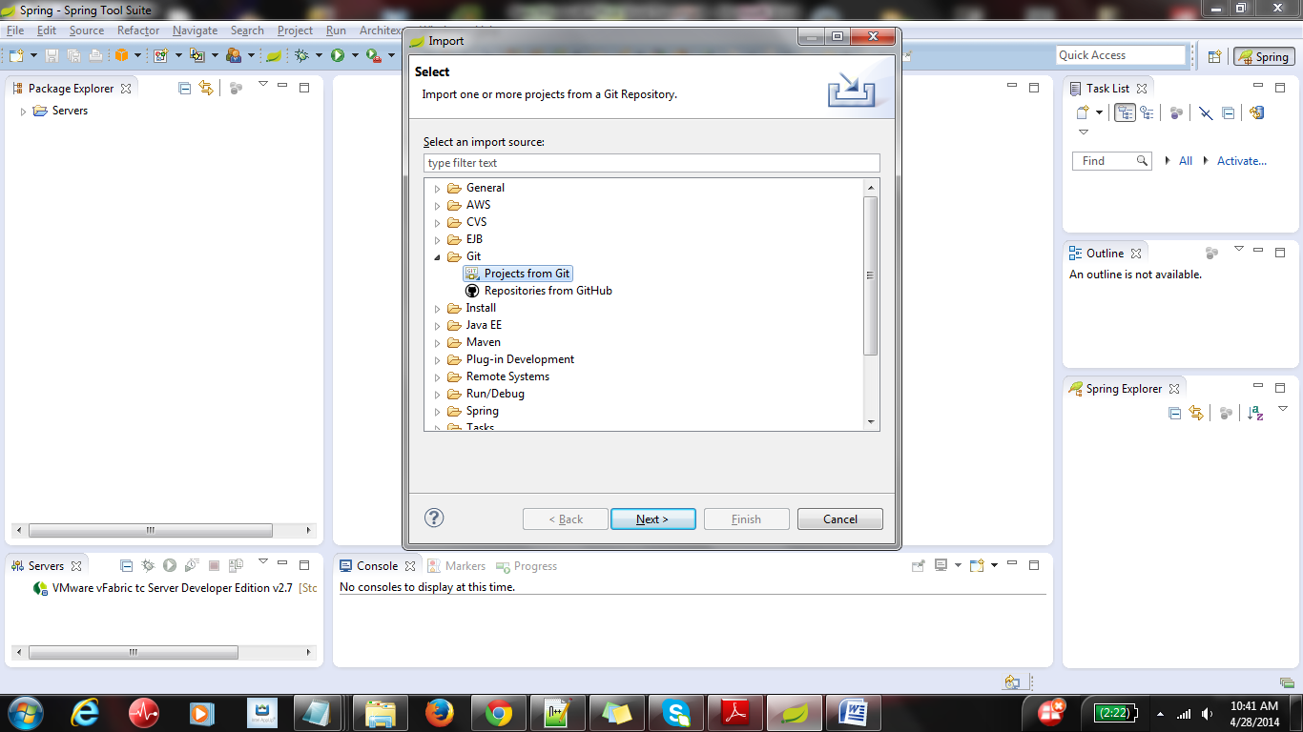

1. In the "Select Repository Source" tab, select "Clone URI" (if you don’t have eTaap code in local git repository) and press the next button.

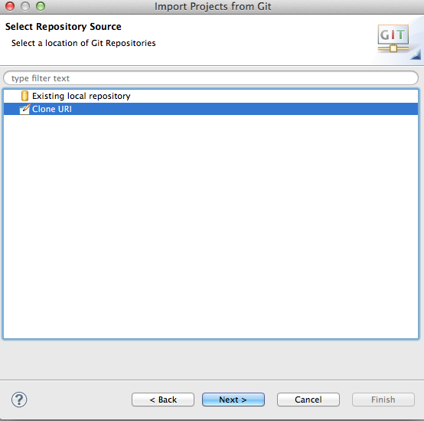

* 3) In eclipse, in "Source Git Repository" tab, enter the URI <https://github.com/etouchsystemscorp/Test-Automation-Prod.git> in the first text box (URI). Rest of the text boxes should get populated automatically. Enter the Github credentials provided by eTouch (i.e. the Username and Password fields) and select the check box - "Store in Secure Store". Then select Next button.
* 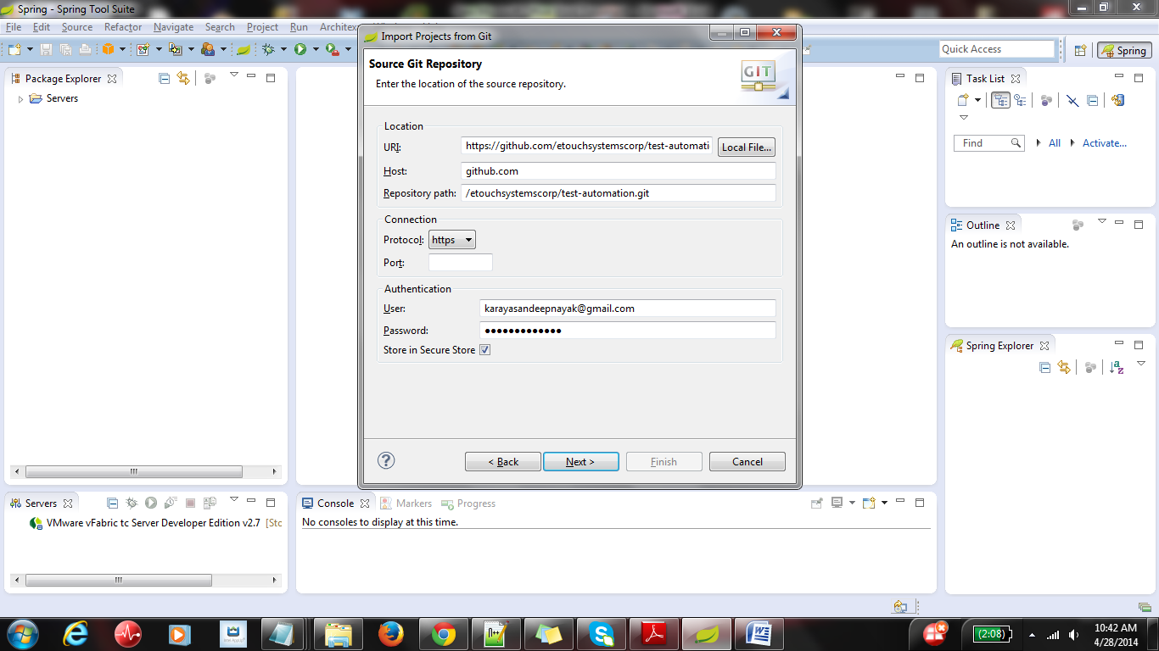

* 4) This should take you to "Branch Selection" page. Here, check the checkbox "master" and select Next.
* 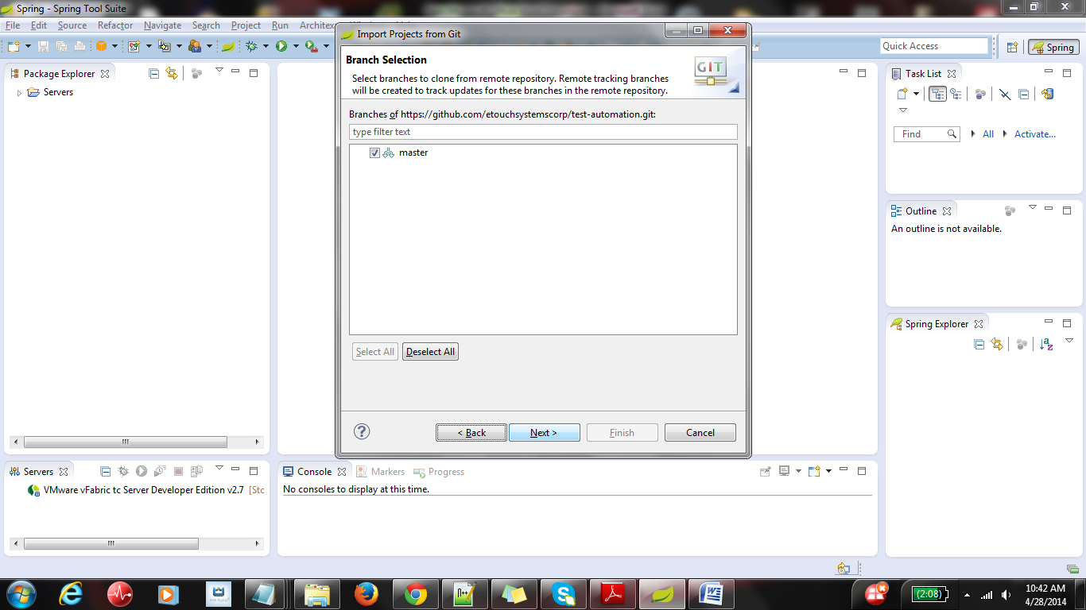

1. In the local Destination tab, mention the local directory, where you want to store the project from Github. Select Next.

* 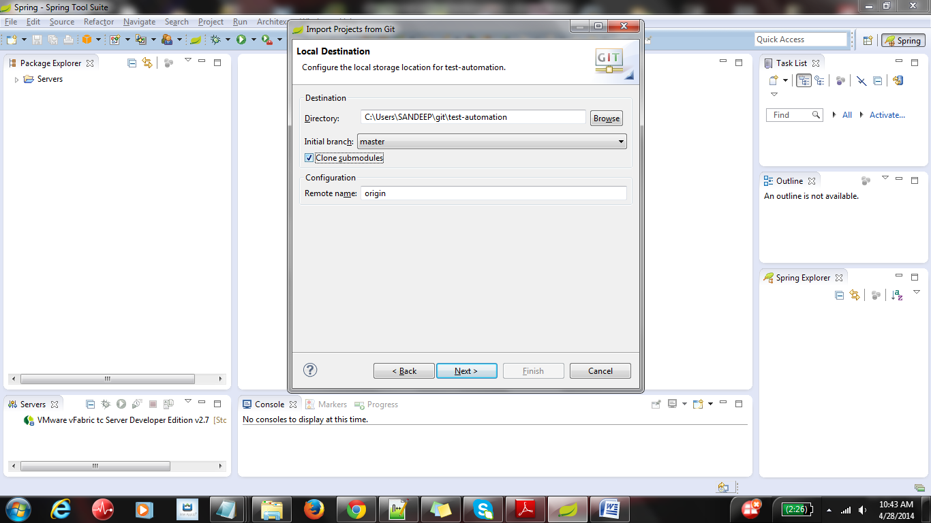

1. You should see the screen as below. Wait till it downloads the files from git hub.

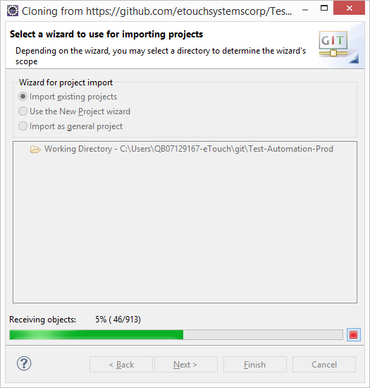

1. Once the download is complete, you should see below screen. Please click on Next

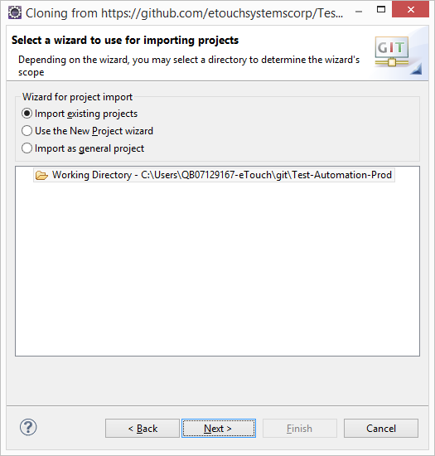

1. Please make sure to select checkboxes next to **AmazonPOC** and **test-automation-library** and then select "Finish".

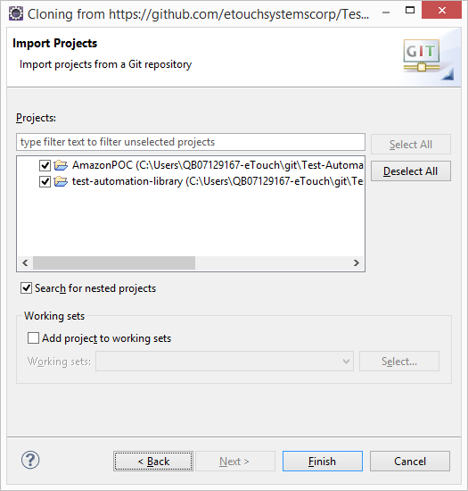

* 9) Wait till the project is imported from GitHub. Once imported, the project should be visible in the project explorer tab in your eclipse as shown in the screen shot below. Please validate the folder structure as per the below screenshot. The projects might have a red exclamation mark indicating missing components or jars.
* 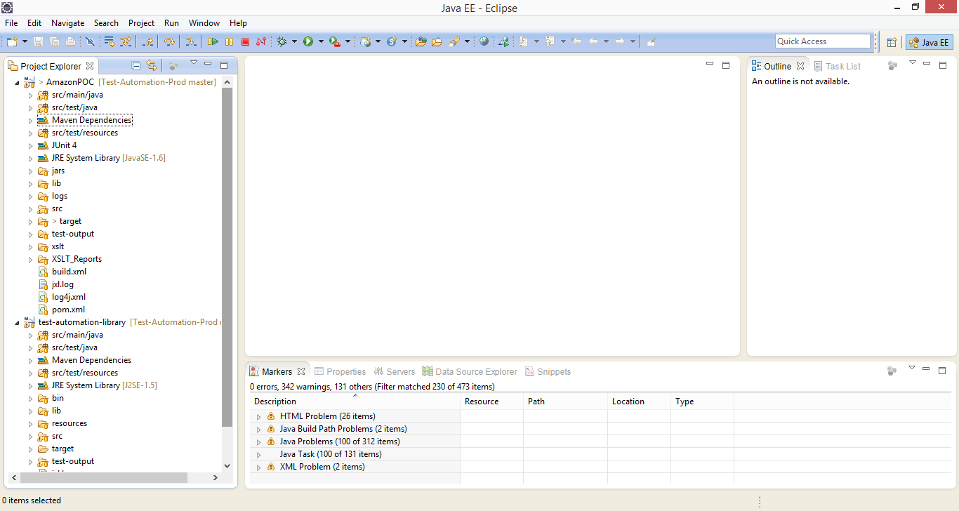

1. Right click on the test-automation-library project, and click on **Run As -> Maven Install**.

* 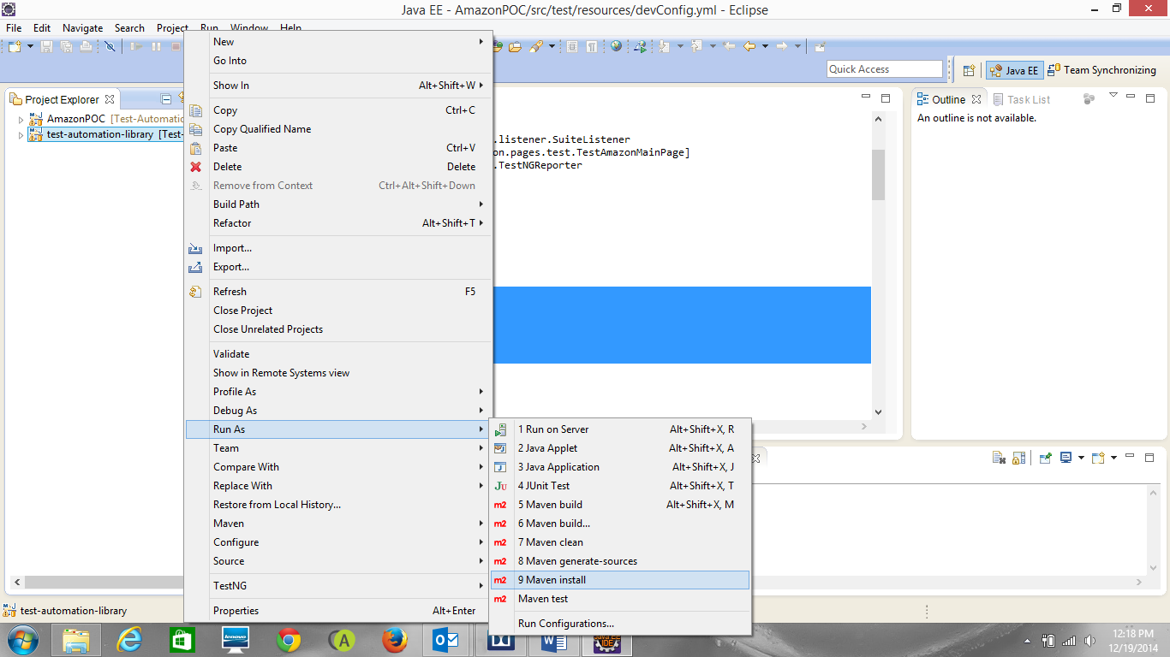

You may see the **BUILD FAILURE** error in the console or red mark on projects in eclipse. To remove these errors, the external dependency needs to be installed in maven local repository. Please install the external jars following the instructions specified below.

## Installing external jars in the local repository

* External jars have to be installed in the local repository for resolving the compilation errors. To do this, follow the below steps:

1. Before running the commands, make sure that Maven is installed in your system. Make sure the below environmental variables are set in the Systems tab.

* MAVEN_HOME = <Maven installation Folder>\apache-maven-3.2.3-bin\apache-maven-3.2.3
* M3_HOME = <Maven installation Folder>\apache-maven-3.2.3-bin\apache-maven-3.2.3
* M3 = %M3_HOME%\bin
* PATH = ;%M3%

1. External jar files can be found at test-automation-library\lib folder. Go to the folder <Eclipse work space root>\test-Automation-library\lib. Run the batch file mvninstall_Windows.bat or mvninstall_Mac.sh as per your platform.
2. Look for “Build Success” in the command prompt console while the batch file is getting executed.
3. Go to **.m2** repository under **Users** folder and verify if the jar files are installed in below paths.
   * <Path to .m2 folder>\repository\com\experitest\selenium\mobile-webdriver\1.0\mobile-webdriver-1.0.jar
   * <Path to .m2 folder>\repository\com\experitest\client\imageClient\1.0\ imageClient-1.0.jar
   * <Path to .m2 folder>\repository\org\monte\MonteScreenRecorder\0.7.5\ MonteScreenRecorder-0.7.5.jar
   * <Path to .m2 folder>\ repository\com\microsoft\sqlserver\sqljdbc\4-2.0\ sqljdbc-4-2.0.jar
   * <Path to .m2 folder>\ repository\com\microsoft\tfs\sdk\com.microsoft.tfs.sdk\11.0.0\com.microsoft.tfs.sdk-11.0.0.jar

**Note:**

1. If you see the error that “mvn cannot be recognized”, please make sure that maven environment variables are set up correctly as described in point 1.

* 2. If you see “BUILD FAILURE” error, delete the .m2 folder from **users/<your user name>**. Go to
* Eclipse, right click on test-automation-library and do Run As-> Maven Install. Try to re run the
* **mvninstall** batch file.

1. Right click on the "test-automation-library" folder and do Maven--->Update Project.

* 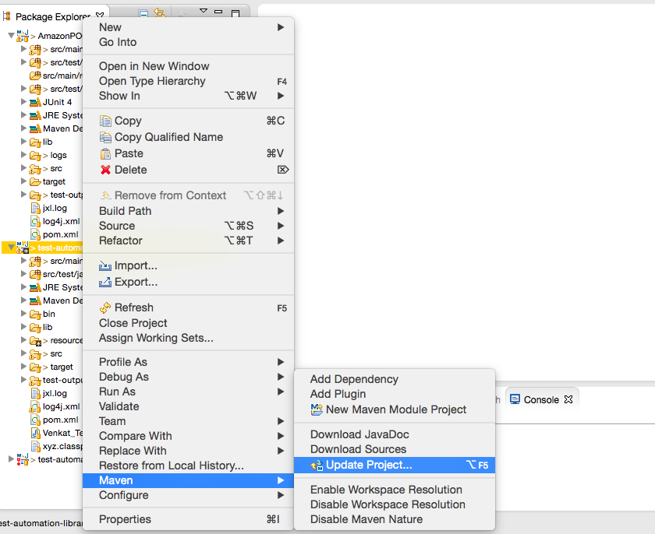

1. Wait for the Maven Update to complete.
2. Right click on test-automation-library folder and click on Run As-> Maven Clean

* 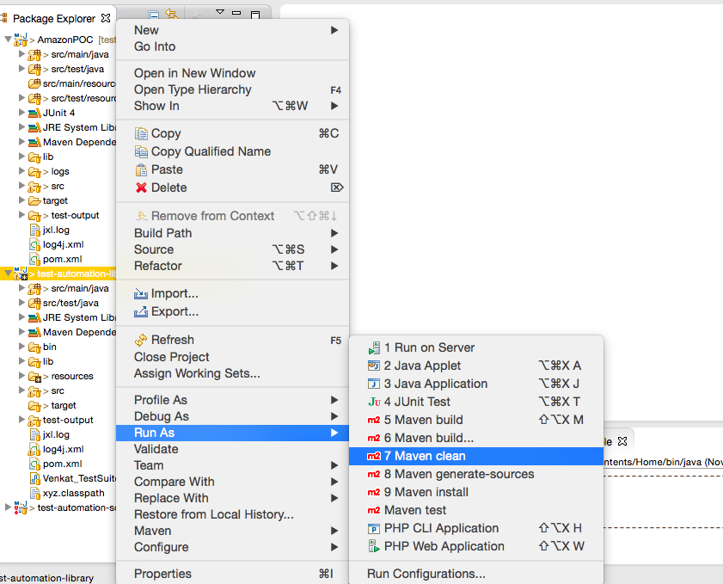
* 14) Wait for the Maven clean to run. The output on successful execution should look like as mentioned in the screenshot below. Look for the word "BUILD SUCCESS" in the console tab.
* 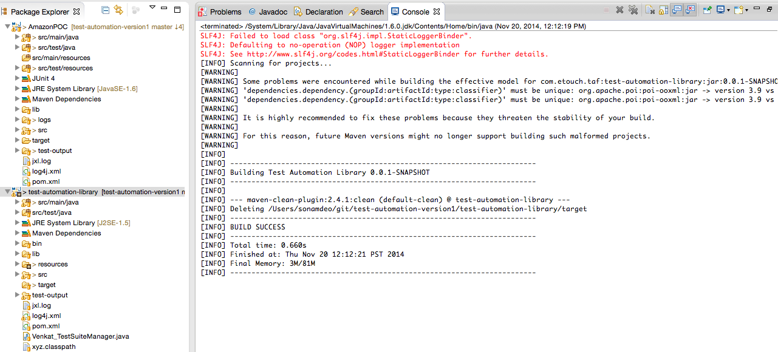
* 15) Right click on test-automation-library and select Run as-> Maven install
* 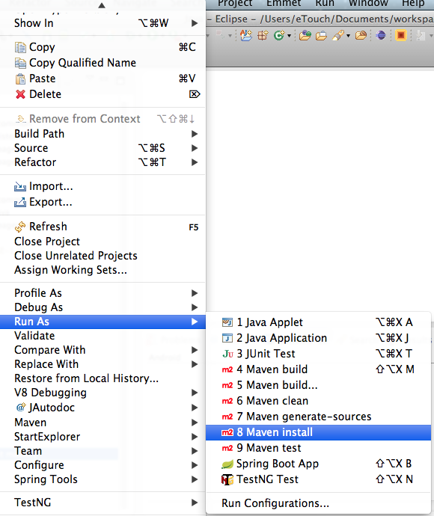

16) Wait for the Maven install to run. The output on successful execution should look like as mentioned in the screenshot below. Look for the word "BUILD SUCCESS" in the console tab.

* 
* 17) Select AmazonPOC and Select Force Update as shown in the screen shot. This step is required while installing the framework. If you are installing eTaap library and AmazonPOC for the first time, please select AmazonPOC and Test-automation-library and “Force update of Snapshots/Releases”.
* 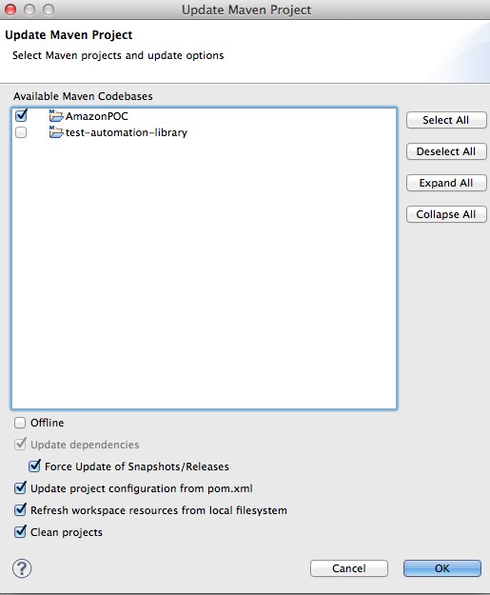
* Once the project is updated, the red exclamation mark (or errors) should be removed.
* **Note:**
* In Windows environment, there is a possibility to throw a JDK error when we are updating both test-automation-library and AmazonPOC. Please refer the below document to fix the issue.

* 
* 18) Open the file TestAmazonUnit.java located at the path /AmazonPOC/src/test/java/com/etouch/amazon/common/TestAmazonUnit.java
* Search for the keyword -"String configFileName" and edit the path as per the location of your workspace. The keyword configFileName might occur at many places. Make sure to change all the occurrences in TestAmazonUnit.java
* 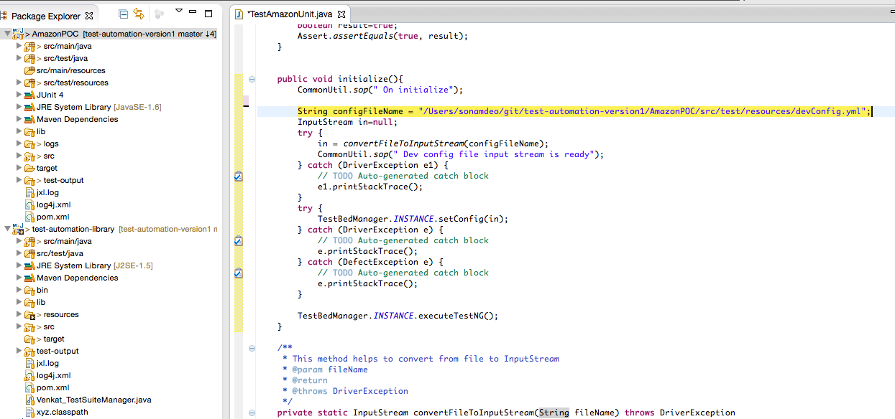

19) In devConfig.yml file, uncomment the **webConfig** information by removing ‘#’ symbol in front of each line under **webConfig** for executing the test scripts in local environment. By default, it will have the remote environment information.

**Existing:**

#webConfig:

#hub: localhost

#port: 4001

#URL: http://www.amazon.com

#tool: Selenium

#testEnv: local

#currentTestBeds: [Chrome]

**To be changed as:**

webConfig:

hub: localhost

port: 4001

URL: http://www.amazon.com

tool: Selenium

testEnv: local

currentTestBeds: [Chrome]

In the same way, you can comment or remove the remote **webConfig** information displayed below from **devConfig.yml** file.

webConfig:

hub: 54.173.15.241

port: 4444

URL: http://www.amazon.com

tool: Selenium

testEnv: remote

currentTestBeds: [Chrome]

20) Do the Maven clean for AmazonPoc project.

* 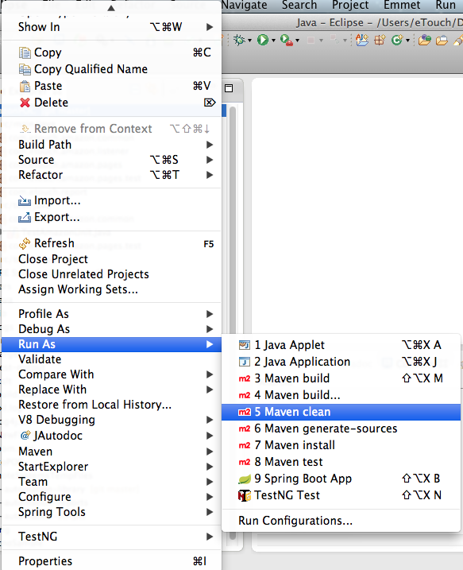

21) Do the Maven Install for AmazonPOC project. The install command also executes the test scripts on amazon site.

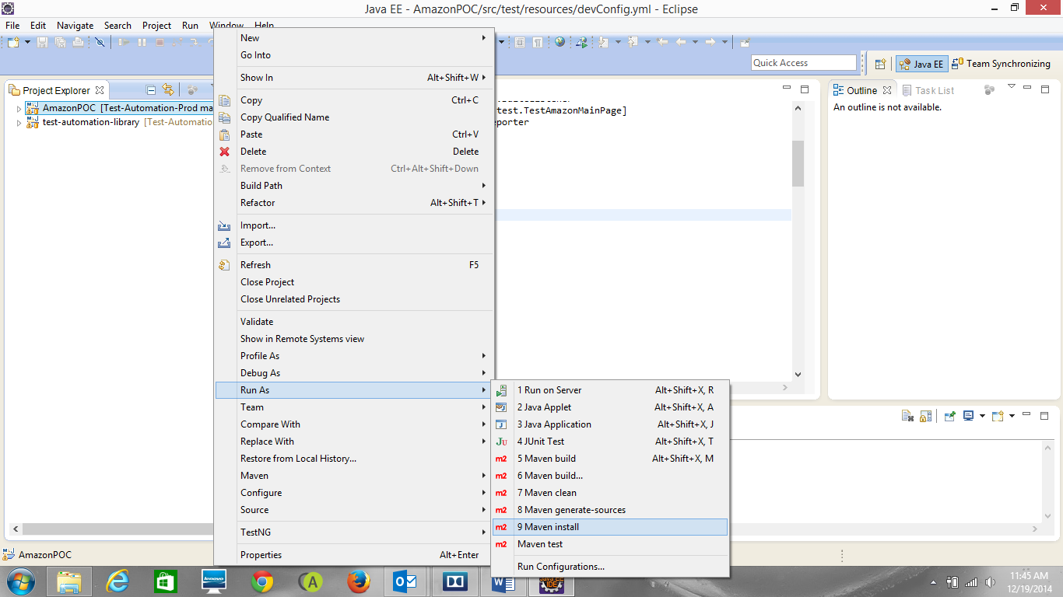

Run As -> Maven Test can also be used to execute the test scripts.

* Right Click on the project and Select "Run As--> Maven Test"
* 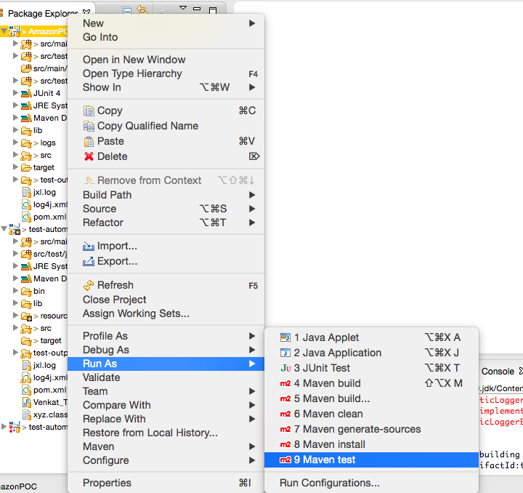
* After this step, Amazon POC should run as a maven test without error. The application opens Amazon.com and performs basic test cases on it. This completes the project installation from Git hub.

## Generating XSLT reports

To generate the XSLT reports after the tests are run, please run below commands in command prompt.

1. cd <test script project root folder>

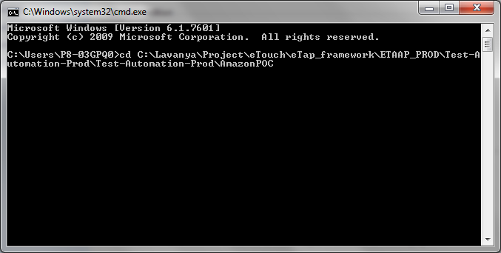

1. ant build

Note: Please look for BUILD SUCCESSFUL in the command prompt.

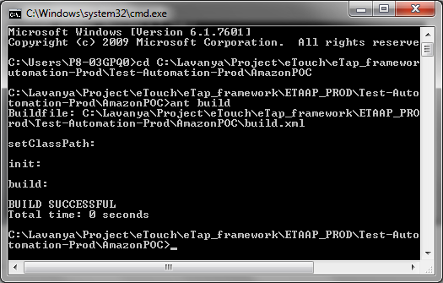

1. ant makexsltreports

Note: Please look for BUILD SUCCESSFUL in the command prompt.

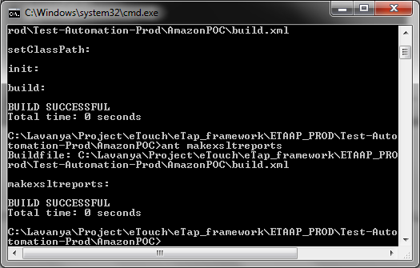

1. You can see the generated reports under the folder <scripting Project root folder>\XSLT_Reports\output

Ex: AmazonPOC\XSLT_Reports\output

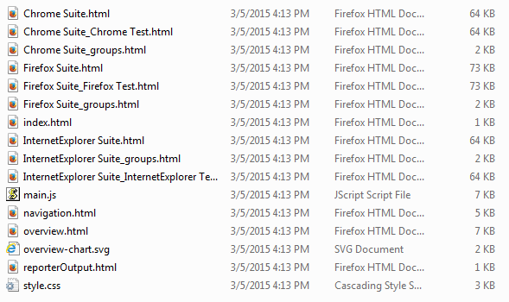

1. Please open the index.hml. From this, you can navigate to other reports.

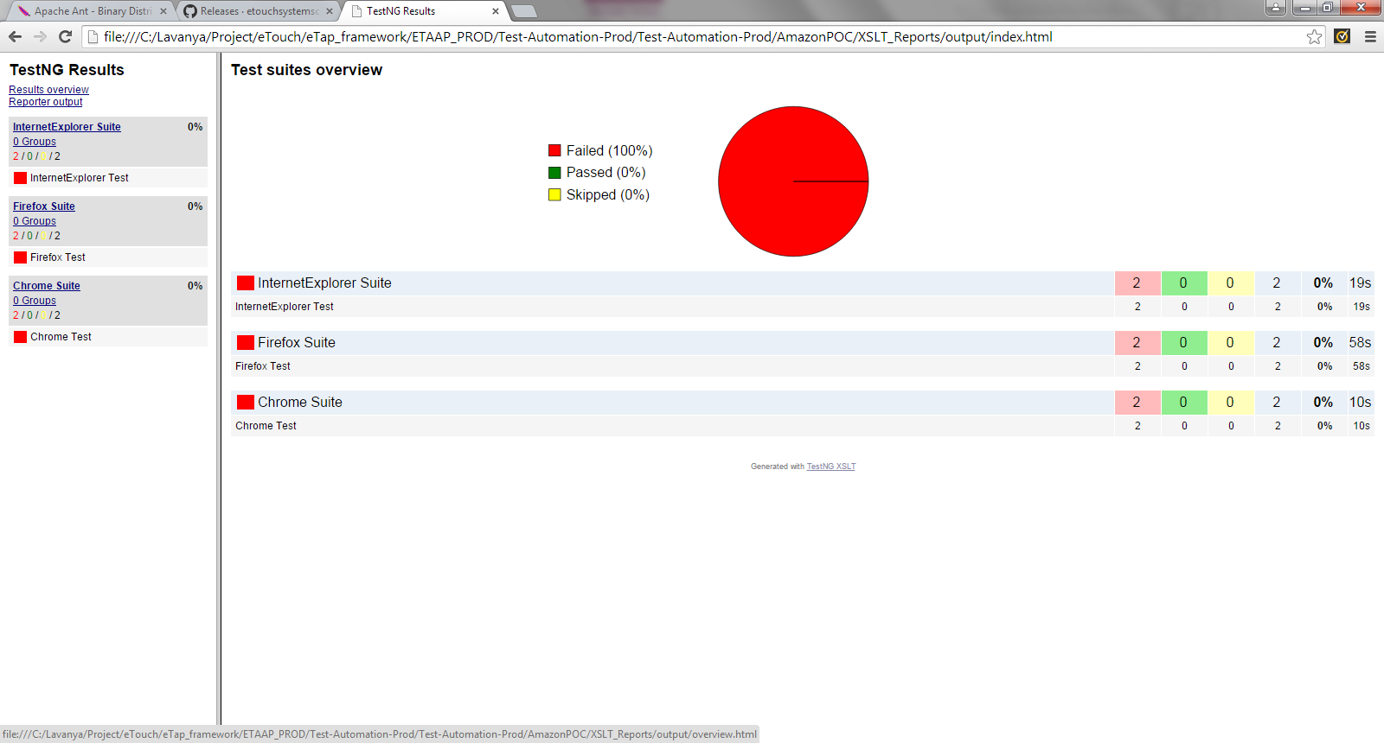

**Note:**

1. When you want to share the reports through mail, please zip the complete **output** folder present under the XSLT_Reports folder.
2. To open the reports which are shared through mail, please extract the zipped reports and then open the index.html.
3. Reports are displayed properly in Firefox browser. Chrome browser does not respond to the filtering action. IE browser does not show the SVG pie chart.

## Fetching the library updates

* **Fetching Latest test-automation-library code from Git hub**

Fetching the latest code from Git hub can be done in two ways.

1. Through Eclipse
2. Through Git Hub Console

**Note:**

**a)** Please take the backup of the local work space before getting the updates from Git hub for safe side.

**b)** Please follow the maven update, clean and install for test-automation-library followed by AmazonPOC, whenever the latest code is pulled from Git hub.

**Through Eclipse**

1. Right click on test-automation-library and go to Team-> Synchronize Workspace

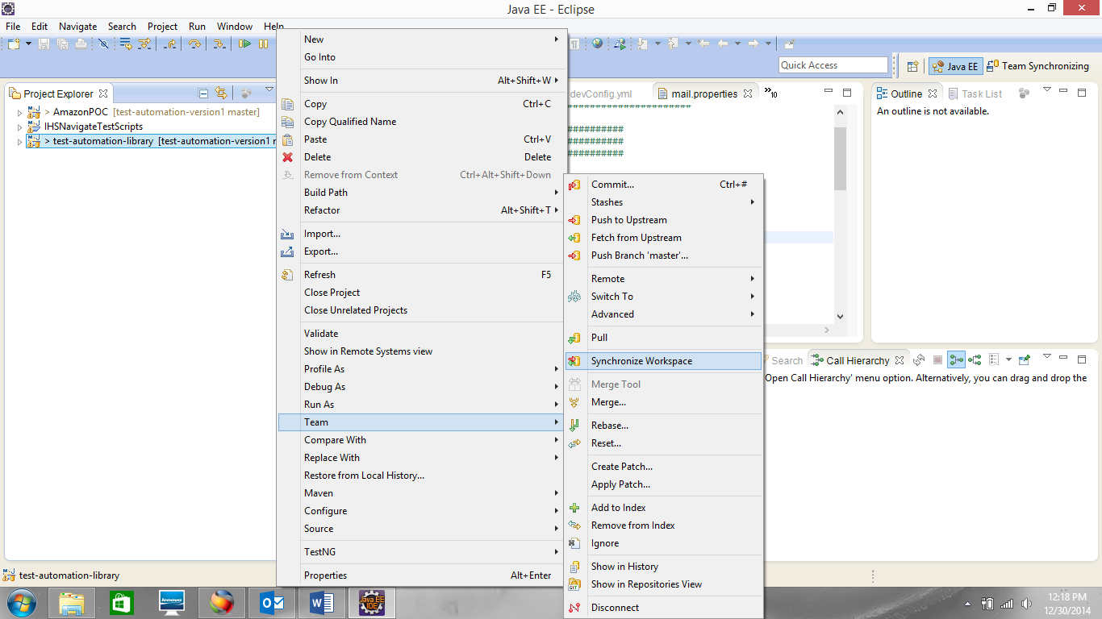

1. A dialogue box opens to confirm for opening the synchronization view. Please click ‘Yes’.

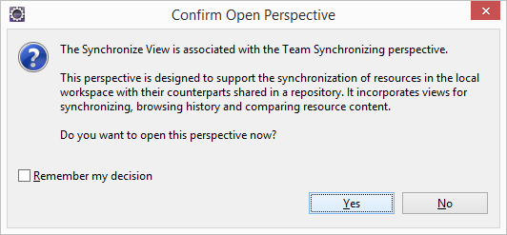

Difference between local and remote workspace can be identified in this synchronization view. The blue colored arrow mark shows the files that got updated in the git repository. The grey colored arrow mark shows the files that got updated in the local work space.

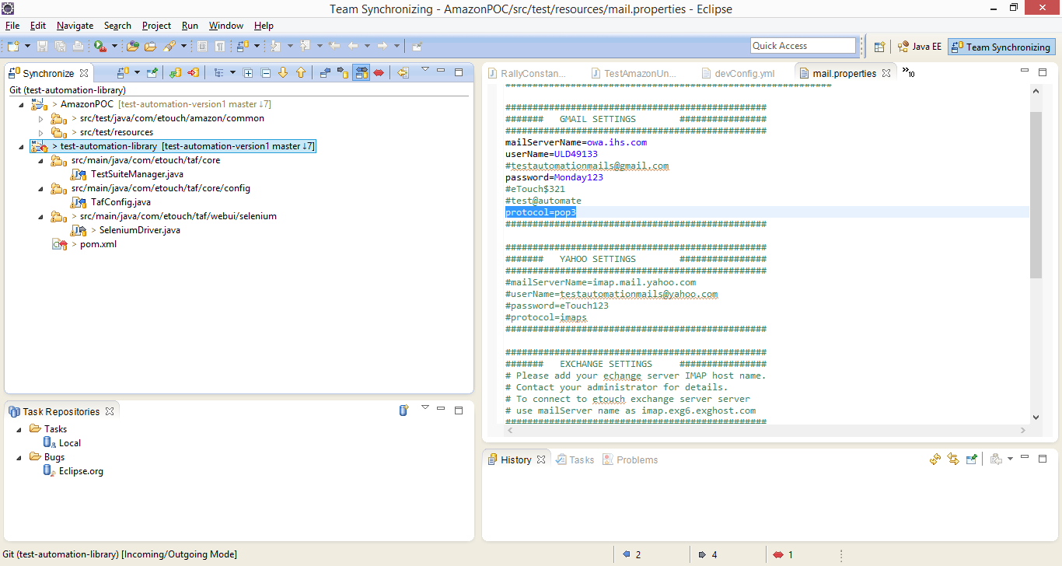

1. Select **test-automation-library** project and click on green arrow mark icon representing ‘pull’ as shown in the screenshot. This fetches the latest code from repository to your local work space.

s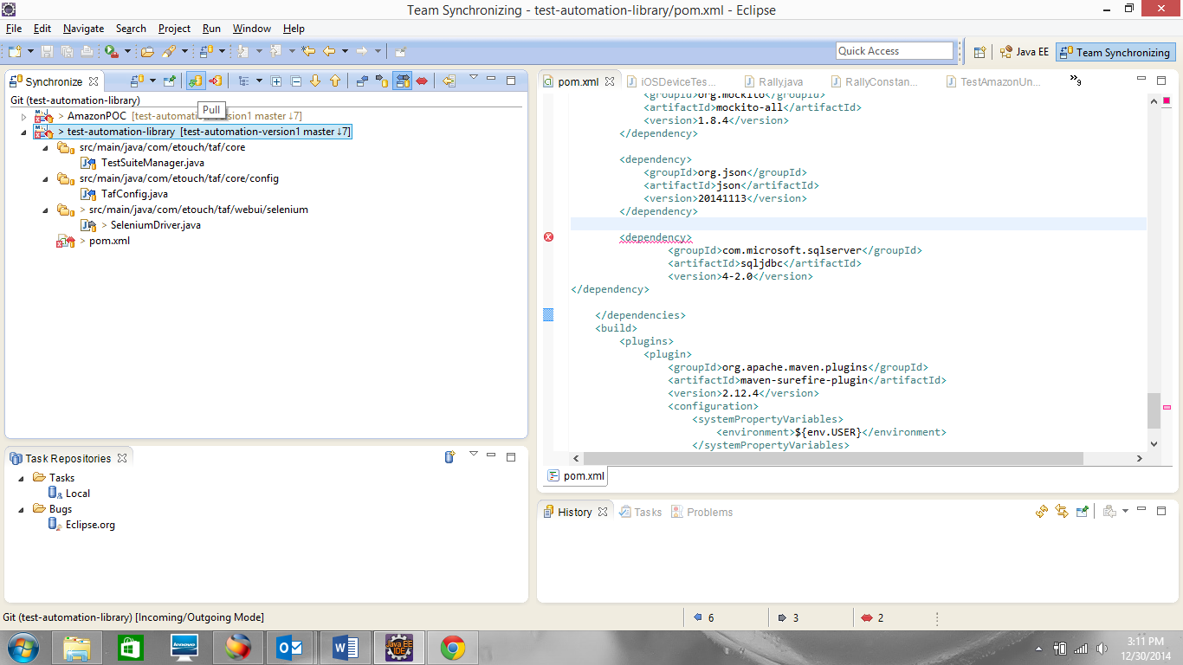

Click on Java EE view to switch to your project view.

**Note:**

If you see red color mark on the project, that identifies the conflicts between local and remote workspace. You can double click on those files to see the differences.

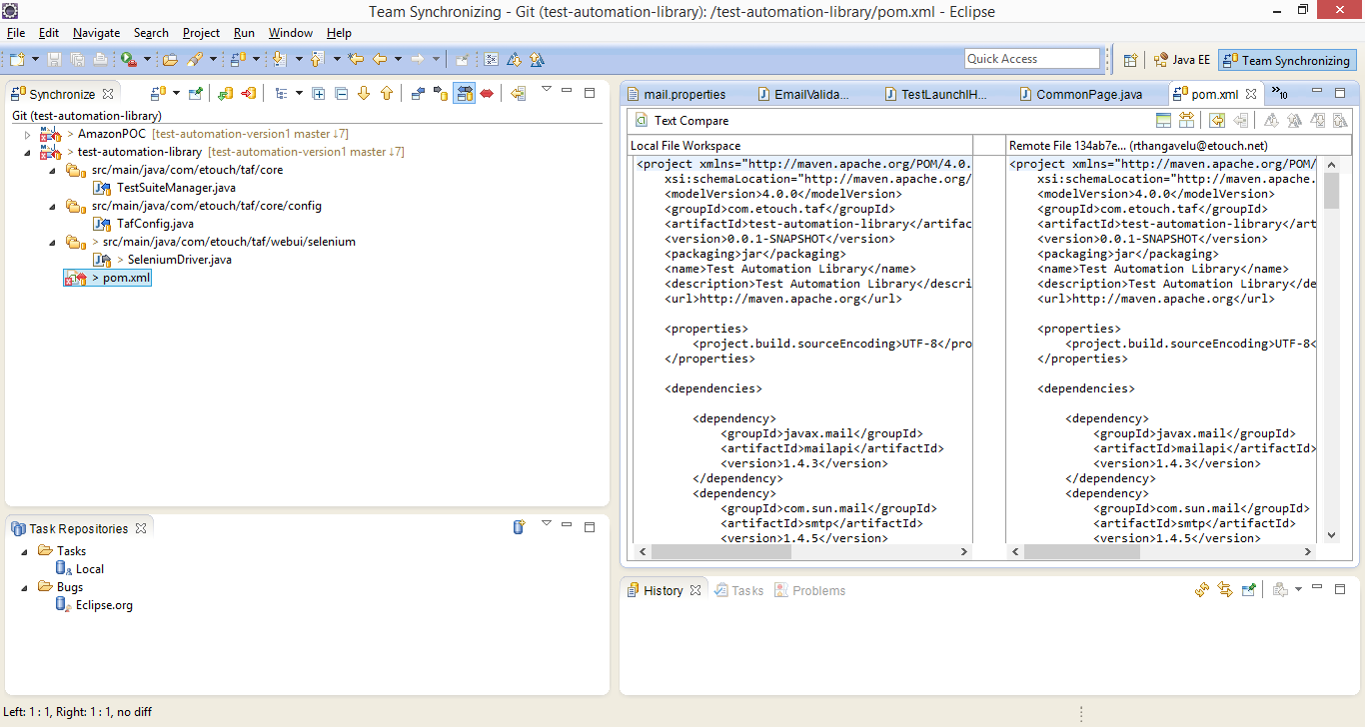

**Note:**

1. If you cannot pull the latest code because of conflicts, you can delete the conflicting files from local work space and pull the latest files from remote workspace.
2. If nothing happens when you try to pull the code from eclipse, please follow the steps to pull the code through Git Hub Console as mentioned below. The console displays the cause why the operation is failing.

**Through Git Hub Console**

1. Please download the Git Bash console for Windows from <https://msysgit.github.io/>

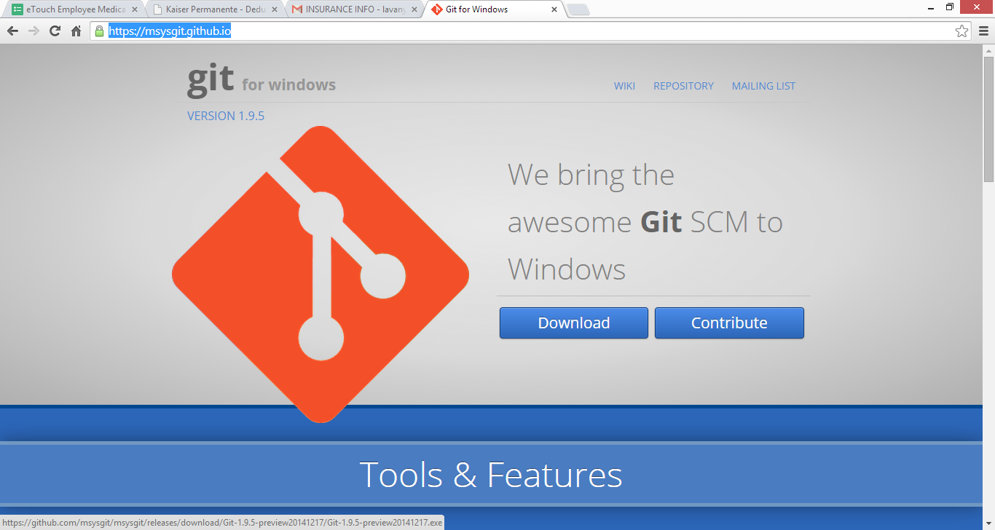

1. Open the git bash console.

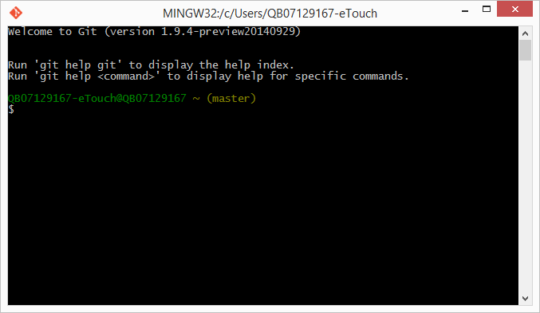

1. Move to the local git repository in your system with below command.

cd “<git repository path>/Test-Automation-Prod”

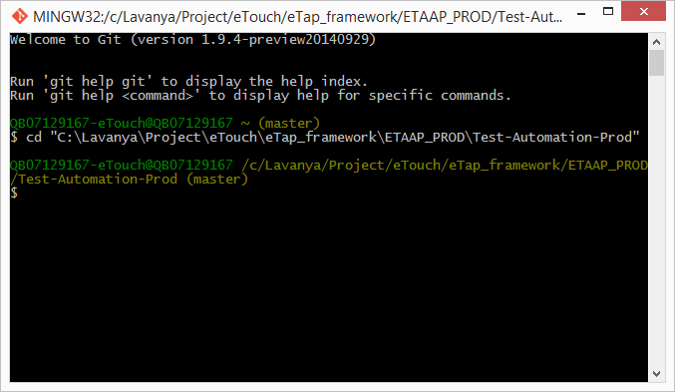

1. Run the command “git pull”. Enter the user id and password for Git hub.

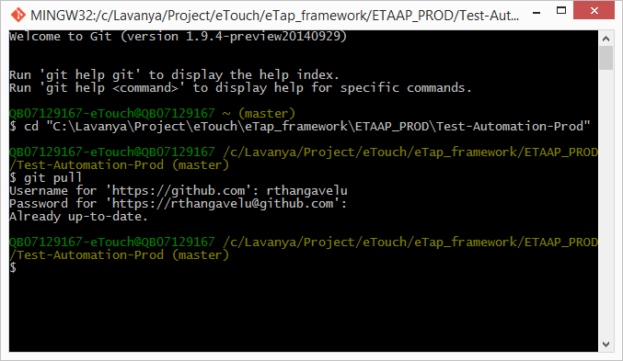

If there are no updates on the remote repository, it shows the message “Already up-to-date”.

**Note:**

If you have conflicts and cannot pull the latest code from git repository, you can use below commands to override the local changes and get the latest code from git repository.

1. git fetch --all
2. git reset --hard origin/master



# **About Test Automation Library**

Following diagram and table shows various components of the automation library.



|  |  |
| --- | --- |
| * **Component Name** | * **Component Description** |
| * **Core Components** | |
| * Web Operations Handler | * Web Operations Handler represents a webpage Class for all common tasks that can be performed on a webpage. This will enable code reusability. |
| * Test bed manager | * Test bed manager is used to setup the test environment for various browser / OS combinations. This will in turn use Profile builder. |
| * Web responsive layout | * Web responsive layout is designed to handle website functionality across multiple screen resolutions. In other words, websites will be available for browsing seamlessly on any device (. smart phones, tablets, net books, or standard monitors) |
| * Send email | * Send email feature is developed to send reports in HTML format via email. The email addresses of the recipients will be configured using configuration files. |
| * **Other Components** | |
| * Selenium Hub/Node Health Monitor | * Selenium Hub/Node Health Monitor will ensure that selenium hub and specific node is available for testing before proceeding with testing. |
| * Jira Integration | * Jira integration is added that allows to log defects in Jira using the REST API |
| * Rally Integration | * Rally will be integrated with Jenkins to log defects in case of any test failures. This integration will enable traceability of a defect to the user story. |
| * Mobile integration | * This component supports mobile web testing to ensure web pages works as expected in Android and iOS browsers. This integration will be achieved using emulators / simulators. |
| * JSON Validation | * JSON data is retrieved from the source location and data structure is validated against the JSON schema. |
| * Utilities | * All utilities are being managed in one package called util. One class represent one utility i.e. reading data from excel sheet, capturing a screen shot, java script executor, and generating a log file. |
| * Data provider | * This component provides functionality to extract test data e.g. read data for excel spread sheet. |
| * Property files | * These files contain default values for the application (browser, platform etc..) |
| * Test Data (Excel) | * Data is provided in an excel file, which is accessed by the data provider using the predefined data locations during the execution of test cases. |
| * Selenium Hub/Node | * This Component setup the Selenium Hub/Node. The Selenium Hub is the central point that will receive all test requests and distribute them to the appropriate nodes. |
| * Rally | * Rally is a planning & management tool. |
| * Mobile Emulators/Simulators | * Mobile Emulators/Simulators provide features to test the application across the mobile devices. |
| * JSON (Payload/Schema) | * JSON payload/schema is the source to provide JSON data and Schema location that will be used for JSON validation. |

File Structure of TAF is as follows:

* 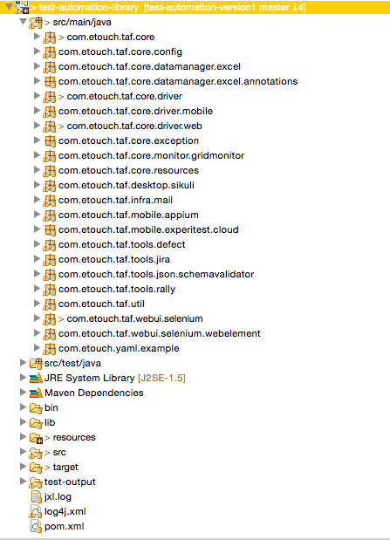
* The following sections of the document describe important classes in some of the packages mentioned above.

## Package - com.etouch.taf.core

### TestBedManager.java

* This class reads the devConfig.yml file and creates profiles based on the data. It calls method to get and set the current test bed.
* setConfig() – based on the ip stream from the devConfig.yml file, this method sets the configurations for defect Config, testng Config, web Config, etc.
* executeTestNG() – builds the test suites and start running the test suite.

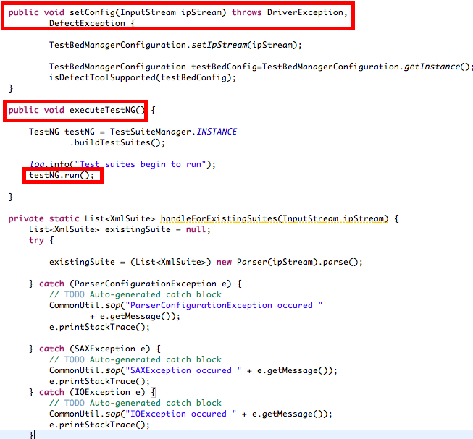

### TestSuiteManager.java

* This class creates Dynamic test suites based on the information from the configuration file.
* buildTestSuites() - This method will read testNG information from TestBedManagerConfiguration and Will create a first testSuite and will createRest of the testSuites depending on the given testbed details
* createFirstTestNGSuite() – This Creates the first TestSuite based on the information given in devConfig.yml under testngConfig.

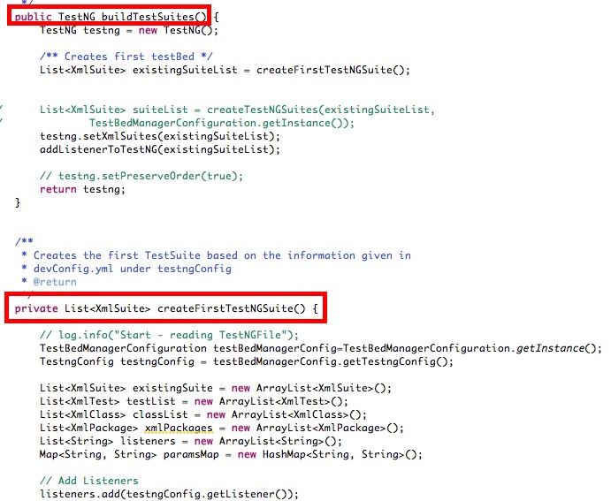

## Package - com.etouch.taf.core.config

### TestBedConfig.java

* This class is primarily responsible for applying setters and getters to the Test Bed configurations extracted from the devConfig.yml file.
* It includes testBed name, device, browser, platform and app name.

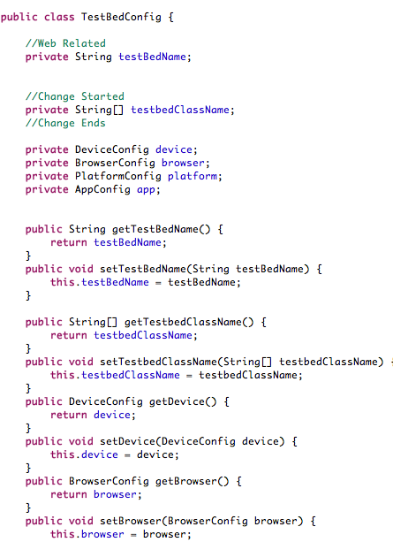

### TestBedManagerConfiguration.java

* TestBedManagerConfiguration creates the main configurations needed for the framework.
* It includes test types, MobileConfig, WebConfig, DefectConfig, DBConfig, testngConfig. The paramaters and their properties are declared under respective config.

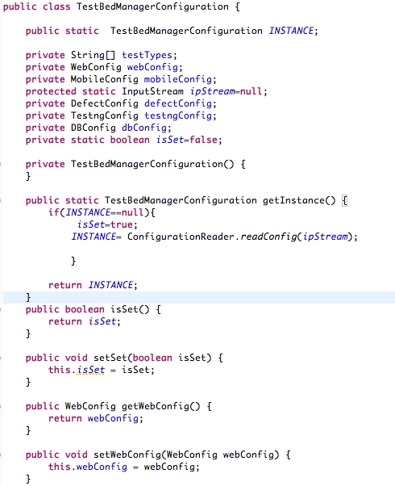

### DefectConfig.java

* This class creates a class that applies setter and getter methods to the parameters under Defect configuration.
* It includes Defect Tools that allows logging defect in Rally or Jira and the parameters needed for it.

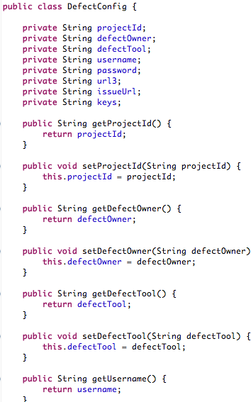

## Package - com.etouch.taf.core.datamanager.excel

### TafExcelDataProvider.java

* This class reads data from excel based on file, sheet and data key. It resolves annotation and construct test data key.
* Loads all data associated with the test class and keep it in TestDataContainer.
* This class reads data from excel based on file, sheet and data key. It resolves annotation construct test data key.
* Loads all data associated with the test class and keep it in TestDataContainer.

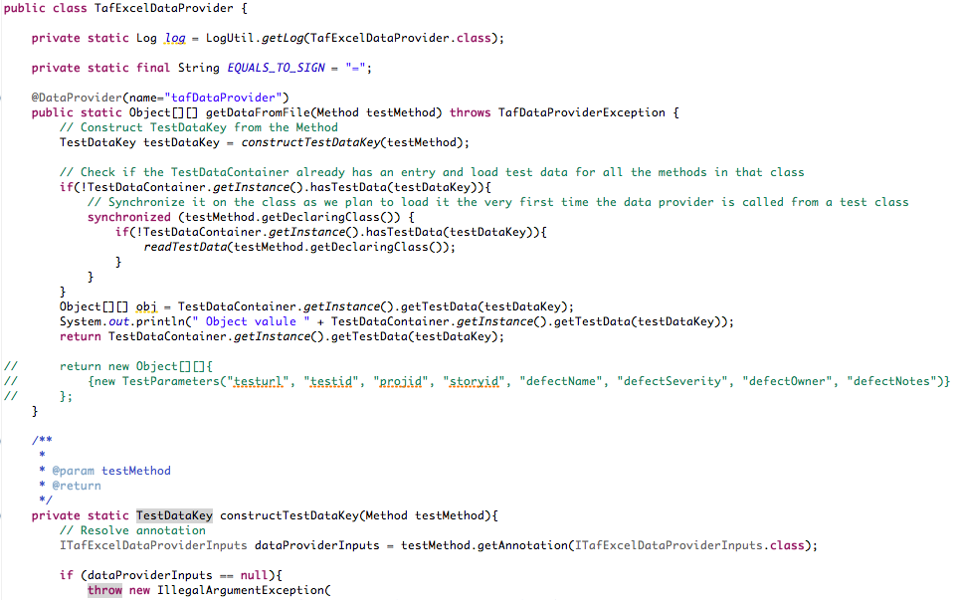

### TestDataContainer.java

* It stores test data.
* The test data is in format of Object Array with TestDataKey as the key to access the test data.
* Any TestNGDataProvider implementation that reads data is expected to store the data here for sharing with other test methods requiring the same data.

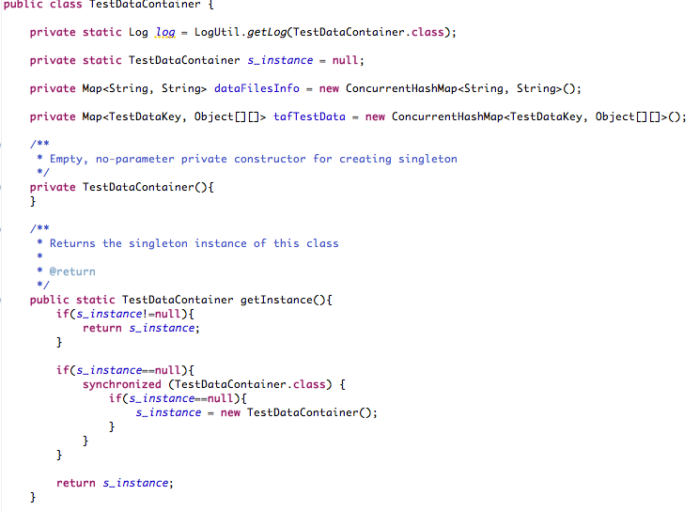

### TestDataKey.java

* This class stores excel data file name, sheet name and data key.
* Objects of this class are to be used as the "KEY" for the elements added to MapTestDataContainer.

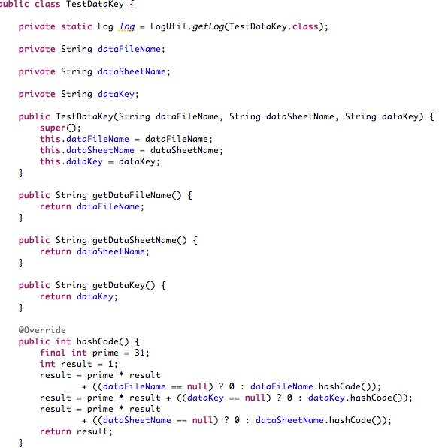

## Package - com.etouch.taf.dataprovider.annotations

### IExcelDataFiles.java

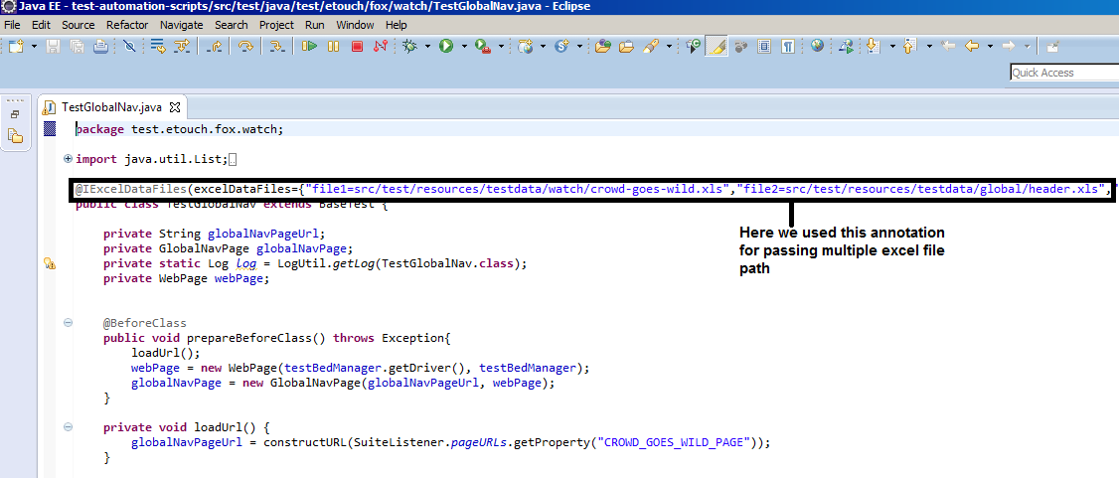

### TafExcelDataProviderInput.java

* Annotation to be used with each test method to denote excel file, excel sheet and data key of test data needed for that method. We used this annotation in Test class file in following way
* 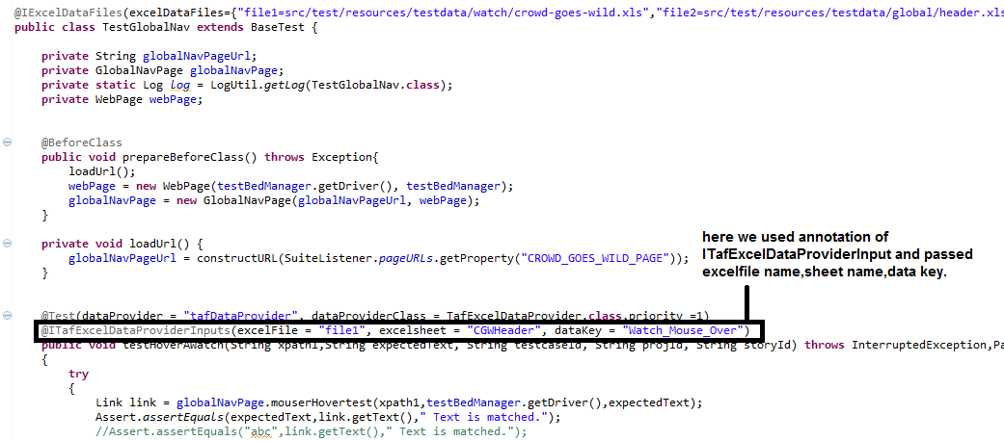

## Package - com.etouch.taf.core.driver

### DriverBuilder.java

* This class builds the browser stack according to the desired capabilities.
* The method buildBrowserstackCapability (), sets the desired capabilities like platform, os version, os name, browser name and browser version for the current test bed. It builds the remote web driver based on the capabilities.
* Method buildRemoteCapabilities()- provides hub location.
* 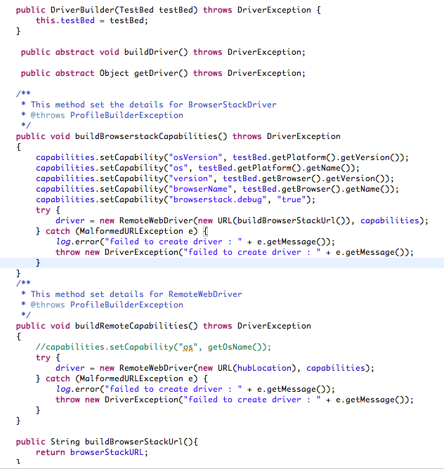

### DriverConstsntUtil.java

* This class builds the browser stack according to the desired capabilities.
* 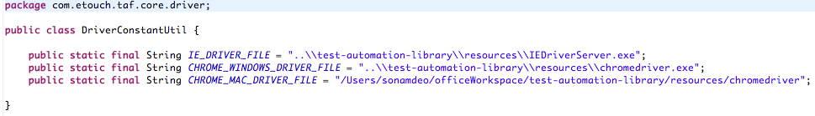

## Package - com.etouch.taf.core.driver.mobile

### AndroidDriver.java

* This class builds the mobile driver for Android test bed. The driver is build from the desired capabilities required for the android driver.

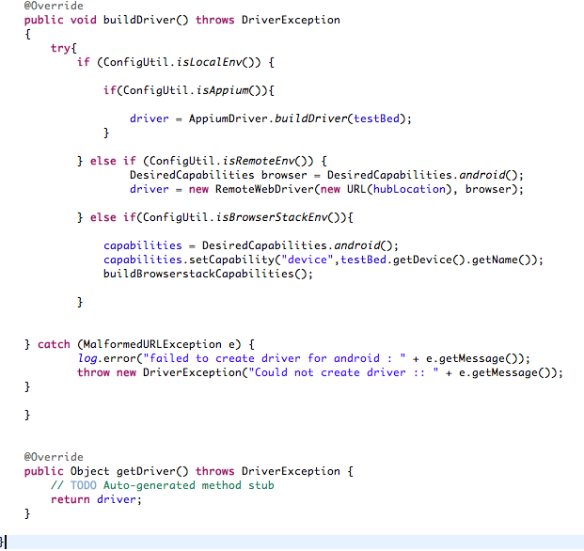

## Package - com.etouch.taf.mobile.appium

### AppiumDriver.java

* This class creates remote Appium driver based on desired capabilities. It creates capabilities depending on the current test bed. It supports mobile test beds that include ios and android related.
* 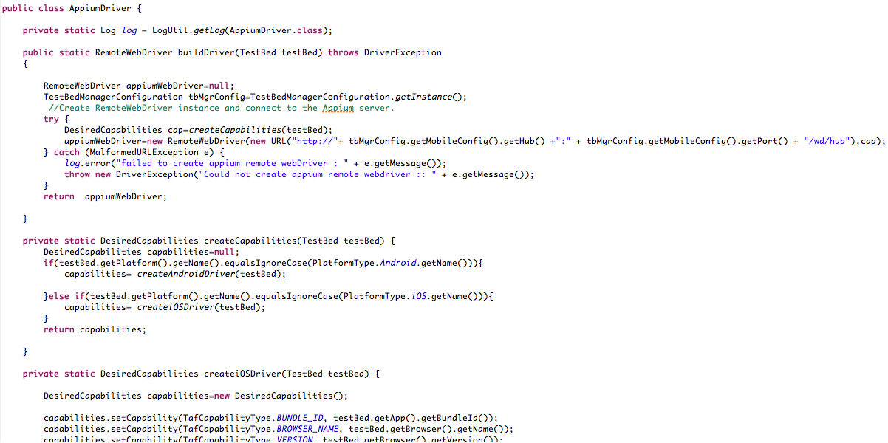

## Package - com.etouch.taf.tools.defect

### IDefectManager.java

* This is an interface that provides methods to perform CRUD operation on Rally and Jira.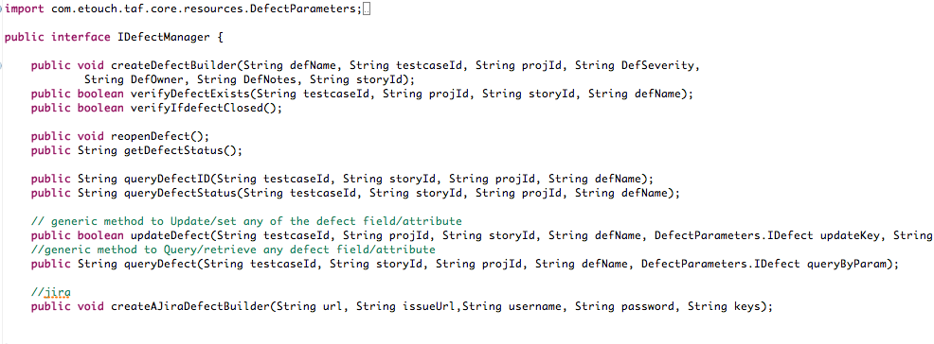

## 

## Package - com.etouch.taf.tools.defect.jira

### jira.java

* This class provides supporting method to access rally data by means of REST api.
* createAJiraDefectBuilder(String url, String issueUrl, String username, String password, String keys) – this method creates request info for performing operations in jira using the parameters.
* createIssue(String url, String issueUrl, String username, String password, String keys) – this method creates issue in Jira using the http rest client and applying Basic Aouth for passing the password through the API.

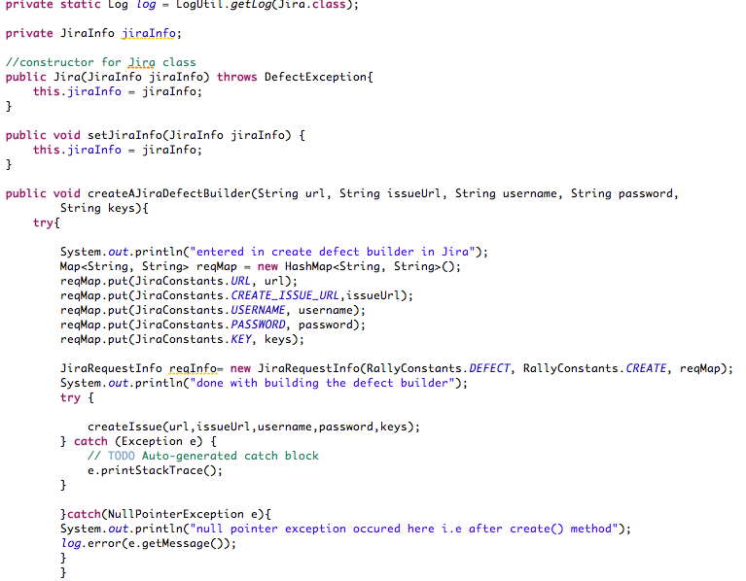

### jiraConstants.java

* This is a constsnts class that contains the required parameters for performing operations in JIRA using the REST API.
* It contains parameters like username, password, url and project key.
* 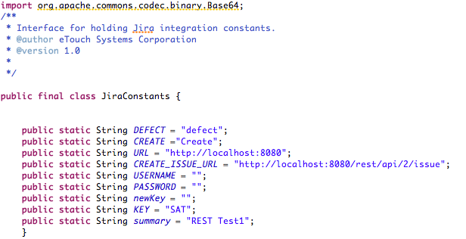

## Package - com.etouch.taf.tools.defect.rally

### Rally.java

* This class provides supporting method to access rally data by means of REST api.
* createDefectBuilder(String defName, String testcaseId, String projId, String DefSeverity,String DefOwner, String DefNotes, String storyId) – This class create a request info comprising of all the parameters to perform CRUD operations on the defect.
* Create(RequestInfo requestInfo) – This method creates defect based on the request info generated from above method. The defect is created in Rally using this method. It also adds any attachments associated with that defect in Rally.
* createInstance() – This method creates a Rally instance using the Rally URL, username and password. This method is required every time for logging defects, test cases or attachments’ into rally using the rest api.

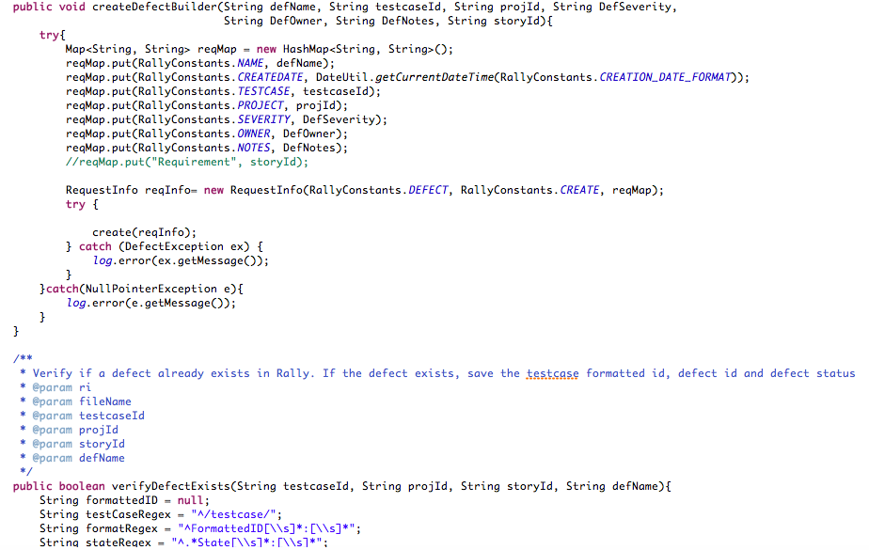

### RallyInfo.java

* This class stores information used to connect rally instance.
* It provides getters and setter methods for rally URL, username, password, wsapi version and app name
* 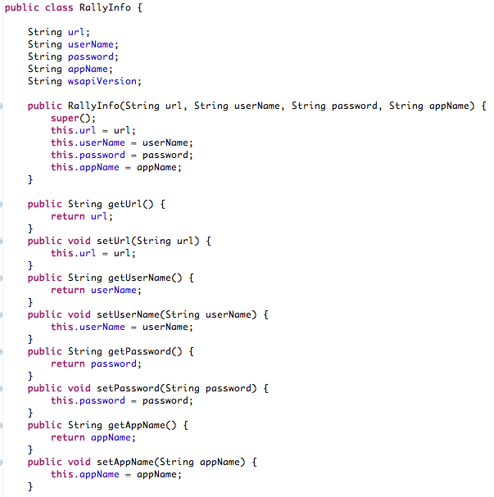

## Package - com.etouch.taf.util

### CommonUtil.java

* This class provides common utility functions.

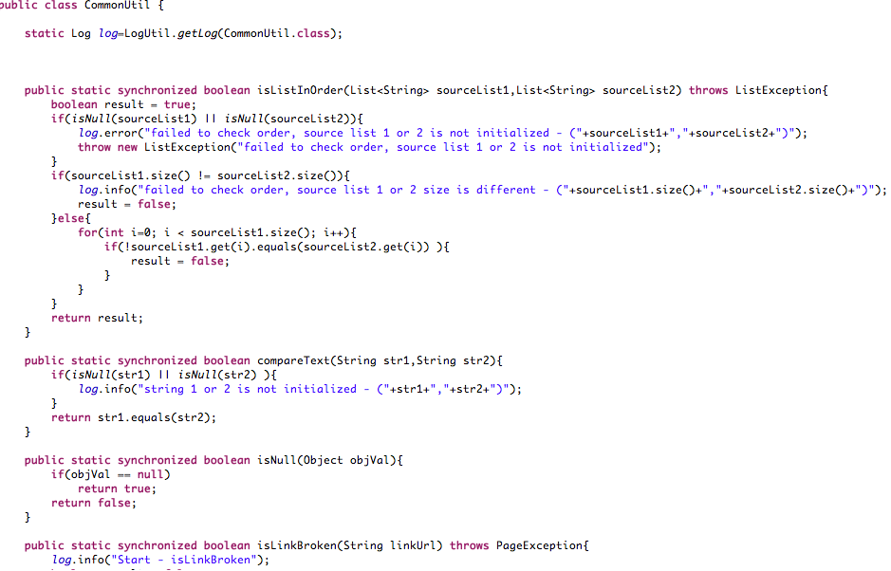

### ConfigUtil.java

* This class provides configuration specific utility functions required in the framework.
* It gets the instance of TestBedManagerConfiguration extracted from devConfig.yml file. It also gets the test environment for testbeds under webConfig.
* It provides Boolean methods to check for the platform of the testbed. Methods are provided for Windows, mac, Linux, android, ios and firefoxOS
* It also indicates the environment under which the tests are specified to run. They include local and remote and further testing tool based on the environment.

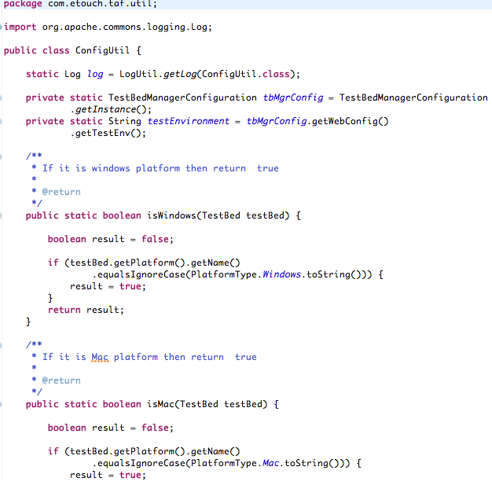

## Package - com.etouch.taf.webui.selenium

### SeleniumDriver.java

* This class provides methods for building drivers for the respective test beds.
* Test beds included for web configurations are Firefox, Chrome, IE and safari.
* Drivers are build depending upon the current test bed, test environment and test tools.
* Test environment include local or remote environment.
* Test tools include Selenium or Appium for web and mobile config respectively.

s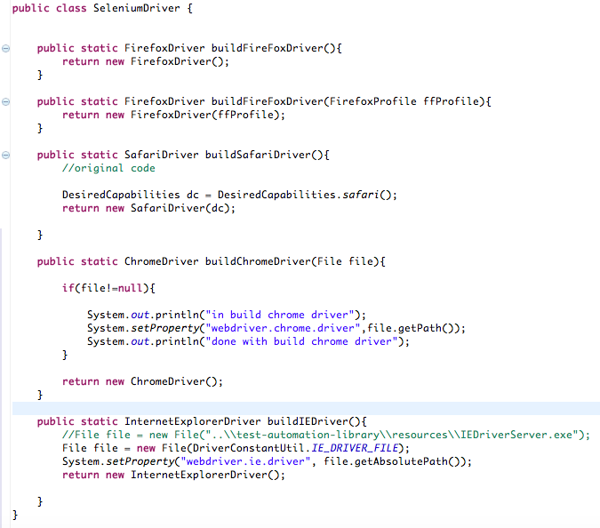

### WebPage.java

* This class finds and renders page objects, drivers.
* webPage() – this method initializes web driver and test bed manager.
* loadPage() – this method loads web page URL.
* This class also provides methods to find objects on web page using ID, CSS selectors, Xpath, class, link, partial link, name etc.
* **s**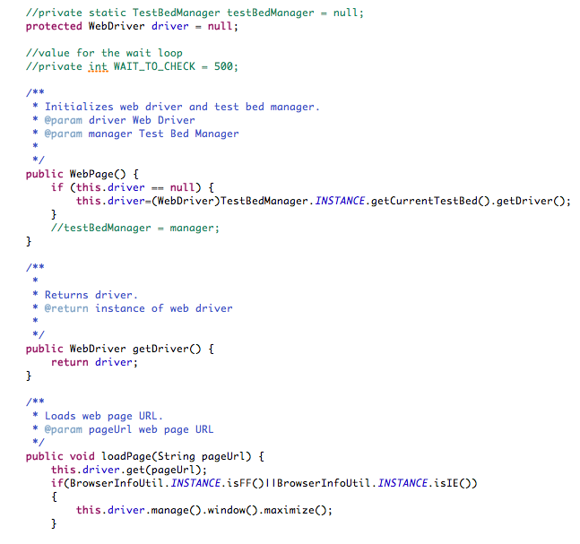

# **Amazon POC**

* Test-automation library is related to Framework and Amazon POC is related to test cases.

## About Test-Automation-Scripts

* File Structure for test-automation-scripts is as follows

s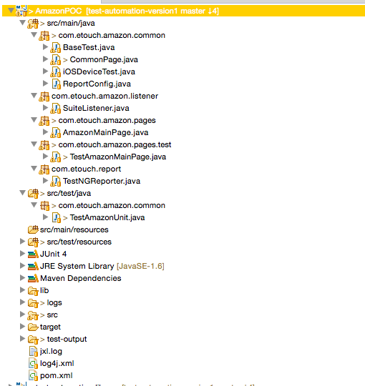

### Pom.xml

* Maven is build tool and pom.xml is main file for project. The pom.xml file is the core of a project's configuration in Maven. It is a single configuration file that contains the majority of information required to build a project in just the way you want inside pom.xml file we can add all needed dependencies for project.

s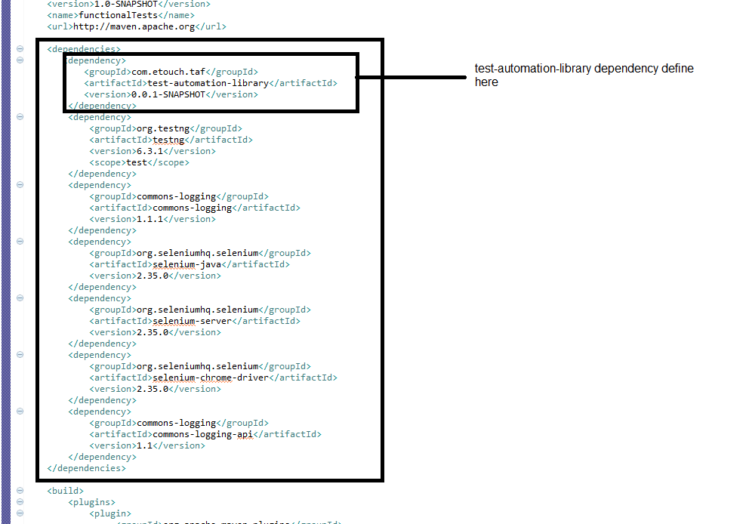

* Also added sb-testng.xml file reference in pom.xml file inside suiteXmlFile Tag.
* 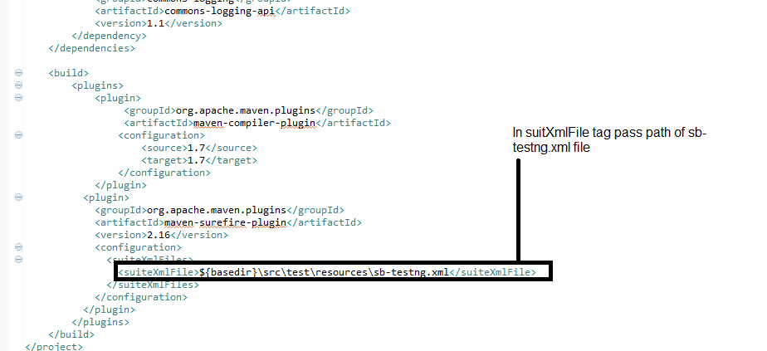

### TestAmazonUnit.java

* It is located at location src/test/java and in package com.etouch.amazon.common.
* TestAmazonUnit is a junit test. As soon as the application runs as maven test, the test will run.
* Initialize() – this method reads the devConfig.yml file and convererts it as per TestBedManagerConfig.java.
* executeTestNG() – this method will build Test suites and execute it one after other.
* convertFileToInputStream() – this method converts the configuration file that is the devConfig.yml file into input stream
* 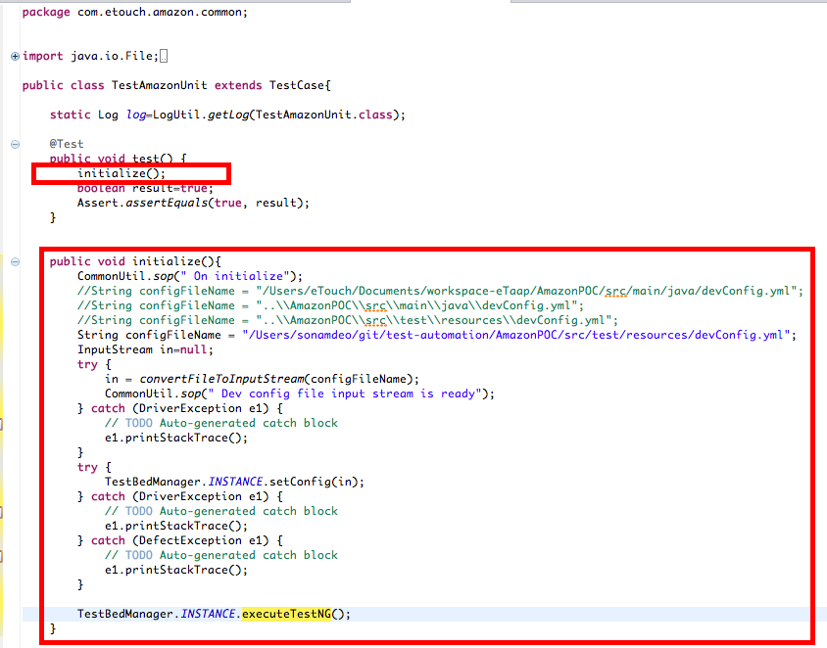

### CommonPage.java

* This file is located in src/main/java and in package com.etouch.fox.common.pages.
* This class contain all common methods which we use for scripts. - This class is called for logging the failed test cases.
* LogAndCreateADefect()-this method can log defects for the failing test cases into Rally or Jira.
* startRecording() / stopRecording() – These methods video records exectution of the test cases.
* getScreenshot() – this method takes screenshot of the failure instance for the test case.

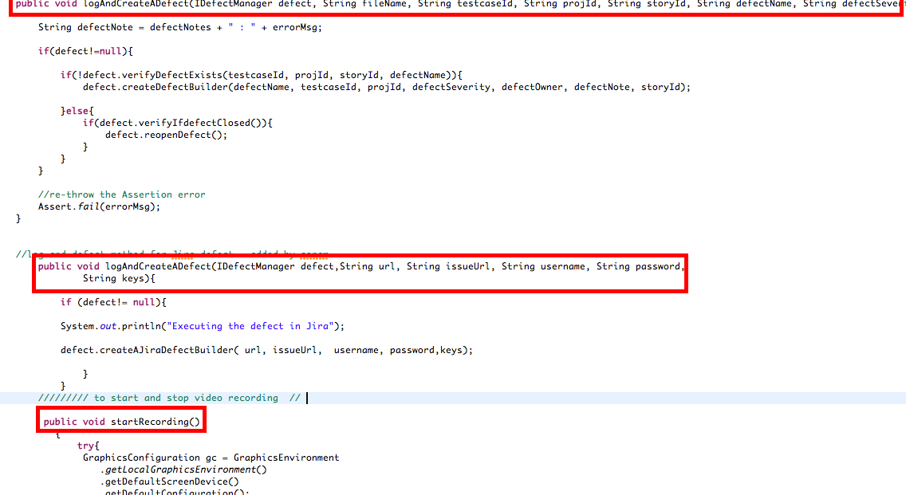

### SuiteListner.java

* This class is called when the test suite begins to run.
* onStart()- this method reads the test suite data and provided the current test bed to TestBedManager. After the current test bed is set, the driver for that test bed is set. After this the test cases begin to run.
* onFinish()- After all the test cases from that test suite are executed, this method is called. It displays the report for the test cases within that suite.

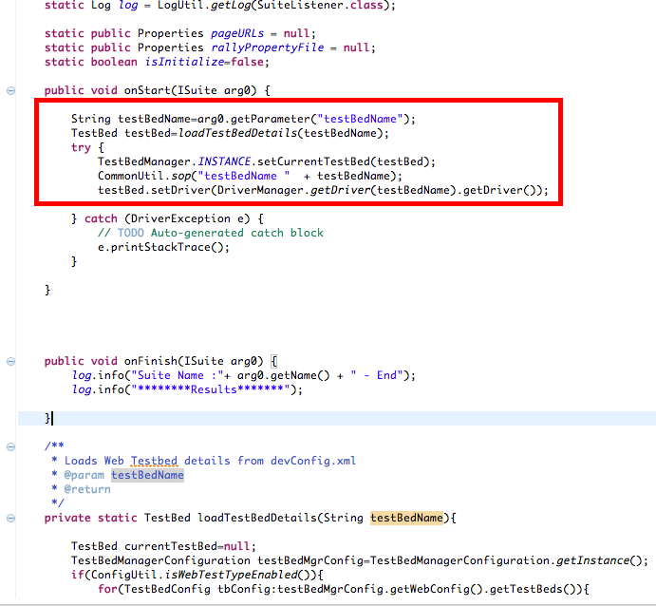

### testautomation.log

* This file is located in test-automation-scripts/logs folder.
* All logs get stored in testautomation.log file.

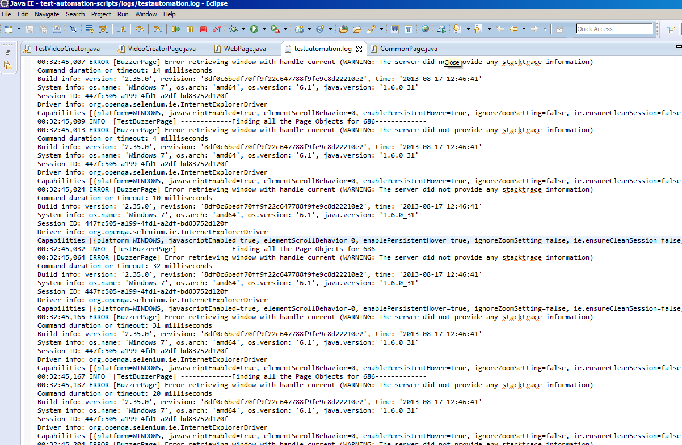

# **Flow diagram**

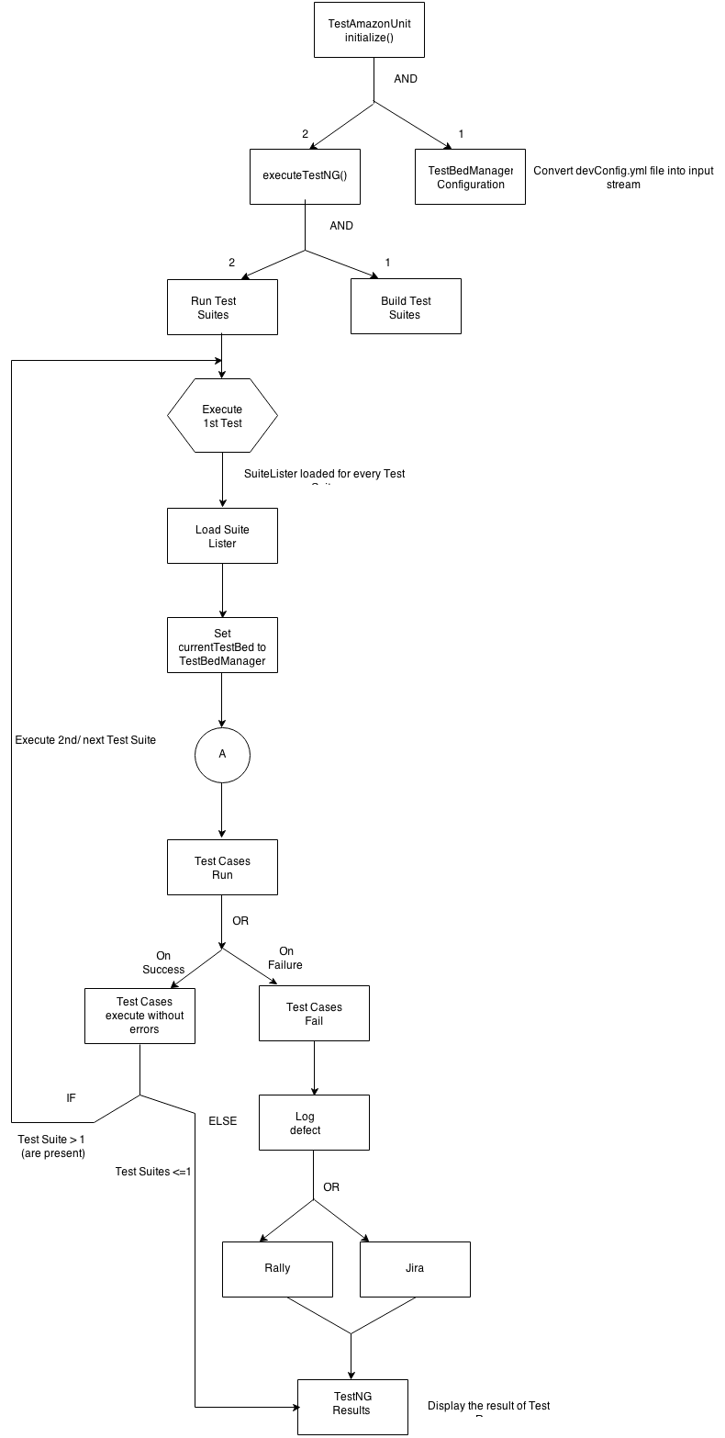

* Driver Creation
* 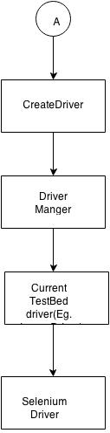

# **Logging Defect in Defect Management System**

* Etaap provides means to log defect in project management software viz Rally and Jira.
* If the test cases fail, a defect can be raised for the failing test case.

## Log the defect in Rally

* In devConfig.yml file, under defectConfig change the defectTool to Rally.
* 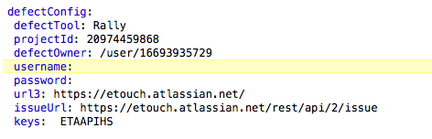
* The method to log defect in Rally should be added to the exception block of the test cases for which defect needs to be logged.
* s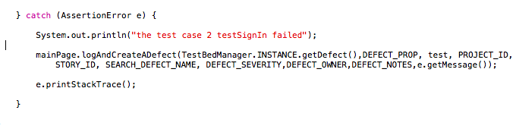
* The implementation of this method is provided in CommonPage.java and it utilizes the package /com/etouch/taf/tools/rally located in Test Automation Library

## Log the defect in Jira

In devConfig.yml file, under defectConfig change the defectTool to Rally

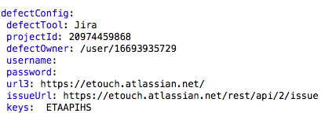

* The jira username and password have to be added.
* The method to log defect in Jira should be added to the exception block of the test cases for which defect needs to be logged.

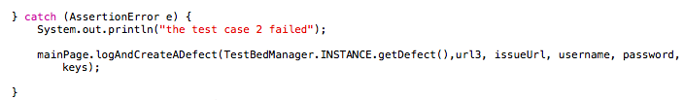

* The implementation of this method is provided in CommonPage.java and it utilizes the package /com/etouch/taf/tools/jira located in Test Automation Library

# **General Information**

* **Driver path not working** -> add the driver loaction with respect to your system to the devConfig.yml file under testBed.
* **Bowser not opening** -> update the browser version, platform name and platform version under testBed in devConfig.yml
* **“failed to read profile configuration/TestNG, file name is missing”** -> If this exception is thrown add the location of devConfig.yml file with respect to your system to TestAmazonUnit.java class
* **To start developing your own test automation project,** create a maven project and add the dependency for including the test-automation-library snapshot jar file. You can refer to AmazonPOC template project – POM.xml for doing this.

# Appendix

Glossary

|  |  |
| --- | --- |
| * **Acronym** | * **Description** |
| * eTaap | * eTouch Test Automation Accelerated Platform |
| * TAF | * Test Automation Framework |
| * TFS | * Teams Foundation Server |

1. eTouch will test with eclipse Lunar and will keep you posted